DAT CAR (Data Accumulation Through Car Altering Remote)
Brandon Davis & Gage Kettering

Final Draft
12/06/2019

CNT 4104 Software Project in Computer Networks
Instructor: Dr. Janusz Zalewski
Department of Software Engineering
Florida Gulf Coast University
Ft. Myers, FL 33965

Copyright © 2019 by Florida Gulf Coast University

Individual Student Contributions to the Project
Student Name | Percentage (%) of Contribution to a Particular Phase | Remarks (optional)
SOFTWARE SPECIFICATION
Brandon Davis | 49% | Good performance
Gage Kettering | 51% | Excellent contribution
SOFTWARE DESIGN
Brandon Davis | 51% | Excellent contribution
Gage Kettering | 49% | Good performance
IMPLEMENTATION AND TESTING
Brandon Davis | 50.5% | Immense Contributions
Gage Kettering | 49.5% | Tremendous Contributions

1. Introduction
1.1 Project Overview
There has been a growing demand for data collection in remote environments. This includes environments not accessible to humans or environments too hot, cold for human interaction, or even environments that have radioactive residue near them. Through a remotely controlled vehicle, one may have the ability to access environments that have yet to be accessed or unable to be accessed by humans in general. This device is designed to gain environmental knowledge on areas a human cannot interact with. The adopted solution named DAT CAR, which is much smaller than a human, offers the ability to evaluate situations humans cannot. The user can control the car from a remote location of their choice using a WiFi connection. For example, if there was a fire that burned down a building, DAT CAR can traverse the tight environment and relay data based on the environment around it, while the user is in a safe environment nearby.
DAT CAR is equipped with a camera that displays what is in front of the car via a live feed. There are also sensors that relay the temperature of the environment as well as the humidity. In order to detect the distance to an object, an ultrasonic sensor mounted on the front of the car is used. This sensor is aimed toward objects in front of the chassis. All of these devices are connected to a predetermined WiFi location with the use of a Raspberry Pi 3 B+ module. The Raspberry Pi 3 B+ is equipped with dual-band 2.4/5GHz 802.11b/g/n/ac Wi-Fi allowing for the data transfer via WiFi [1]
1.2 Project Materials
This section includes a listing of the technologies and materials used to produce the proposed device, as follows:
- Raspberry Pi 3 B+
- Micro USB power cord
- SD-Card
- Portable power supply
- Ultrasonic sensor
- Temperature sensor
- Humidity sensor
- Raspberry Pi camera module
- 4WD Robot Chassis Kit
- AuviPal 5 megapixel Raspberry Pi Camera Module
- Computer monitor
- Working Computer
- REXQualis electronic kit (breadboard, jumper wires, resistors, etc)
- L298N dual H-bridge
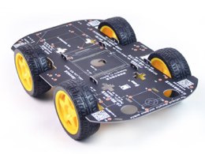
Figure 1: Physical Diagram of DAT CAR system [2]

Figure 1 depicts a four-wheel-drive smart robot car chassis assembled kit that is used as the foundation for the DAT CAR system. The kit includes a PCB car chassis, four TT DC motors, four-car tires, two screw drives, motors wire, and a bundle of screws and nuts.

2. Software Requirements Specification
2.1 Project Objectives
The objective of this project is to create a fully functional DAT CAR device. The rest of this section outlines the project background and specifies software requirements.
2.2 Physical Diagram
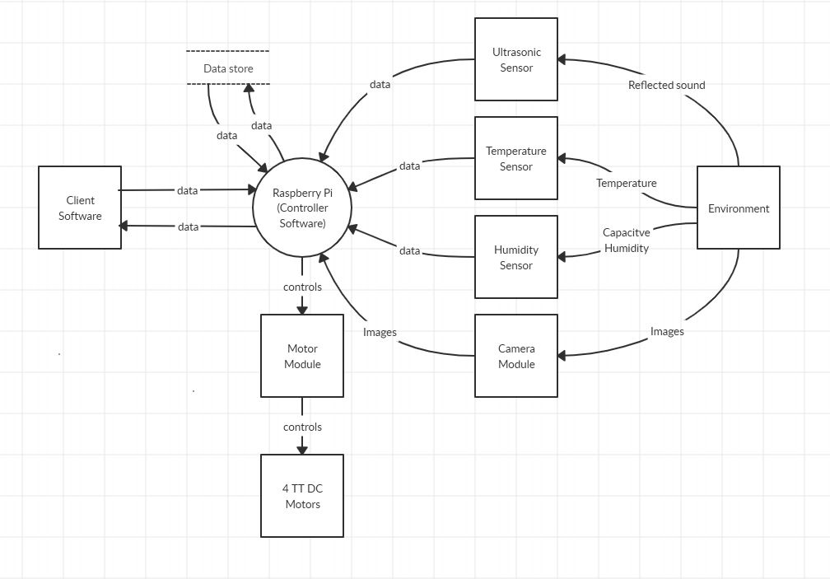
Figure 2: Physical Diagram of DAT CAR

The physical diagram in Figure 2 depicts the interaction with several devices in the DAT CAR. The DAT CAR central processing unit (CPU) utilizes a Raspberry Pi 3 B+ to interact with the end-user. The interaction with the end-user is in the form of displaying various information such as a live video feed, temperature, humidity, and distance of objects surrounding the RC car. The sensor devices connected to the Raspberry Pi process various information from the surrounding environment and send it to the Raspberry Pi controller. The controller sends the information through Wi-Fi to the end-user. In addition, the end-user can turn the RC car left or right and be able to move it forward or backward. The end-user is able to control the RC car with the use of input sent through Wi-Fi and ultimately to the motors of the car. The user can also save the current information being displayed on the GUI.
2.3 Context Diagram
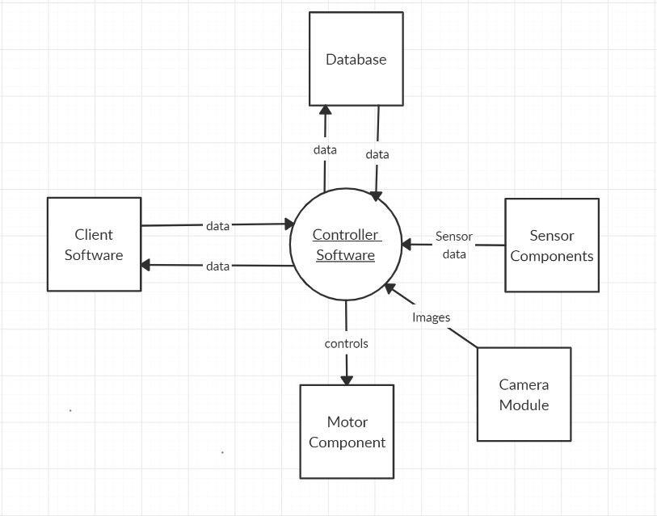
Figure 3: Context Diagram of the Remote Controlled Car

2.4 Software Requirements
The software requirements are specified separately to the controller software and the client software
2.4.1 Controller Software
- The controller software shall establish a webserver.
- The controller software shall implement a GUI to the webserver that serves as the client software.
- The controller software shall be able to save distance, temperature and humidity data into a text file.
- The controller software shall be able to send distance, temperature, and humidity data to the client software.
- The controller software shall utilize a camera and stream images to the client software.
2.4.2 Client Software
- The client software shall be able to handle connection requests to the DAT CAR system through an IP address from a web browser.
- The client software shall display the humidity and temperature of the RC car’s surrounding area to the end user’s monitor.
- The client software shall display the distance of an object in front of the RC car to the end user’s monitor.
- The client software shall be able to store current data being displayed from the system, such as distance, temperature, and humidity.
- The client software shall be able to move the RC car left, right, forward, and backward by clicking the respective buttons on the GUI.
2.4.3 Design Constraints
- The DAT CAR system shall be able to connect to a predefined Wi-Fi endpoint.
- The DAT CAR system shall utilize a temperature sensor and will be able to measure the temperature in the surrounding area.
- The DAT CAR system shall utilize a humidity sensor and will be able to measure the humidity in the surrounding area.
- The DAT CAR system shall utilize a camera and feed a stream to the user’s device.
- The ultrasonic sensor shall be able to measure the distance from 2cm up to 450cm.
- The DAT CAR system shall boot up in under 30 seconds after it is turned on.
- The ultrasonic sensor shall be able to calculate distances within 2 seconds.
- The robot chassis of the RC car will be able to handle a load up to 500g.
- The response time of DAT CAR from user input shall be less than 5 seconds.
3. Design Description
3.1 Software Architecture
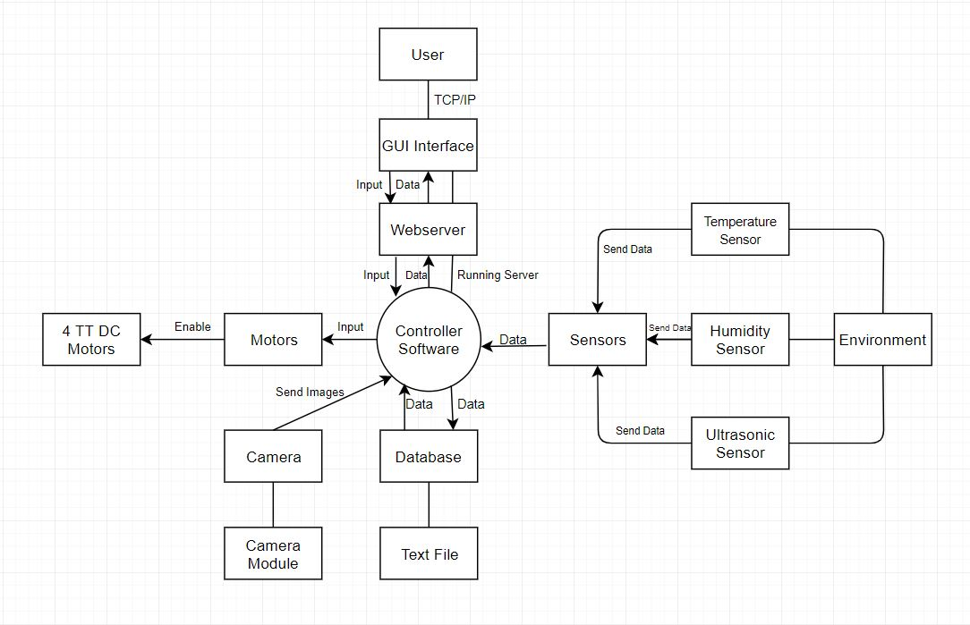
Figure 4: Software Architecture of DAT CAR

Figure 4 represents the Software Architecture for DAT CAR. The figure depicts how the data is transferred from the sensors to the database as well as displaying the data for the user on the GUI interface. The user also inputs the controls that interact with the motors and the database. The Controller Software (Raspberry Pi 3 B+ module) is the core of the entire system; it is transferring the data as well as giving power to the sensors in order to gather data. In addition, the controller software establishes a server that the end-user can connect to and view the GUI. There are five components to the software architecture, which are the sensors, motors, camera, database, and the webserver that the controller software establishes.
3.2 Detailed Design
3.2.1 Software Structures
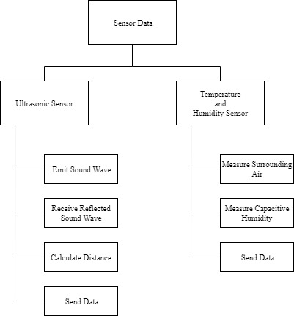
Figure 5: Sensor Structure Chart

Figure 5 depicts the structure of the sensors in DAT CAR. The ultrasonic sensor emits sound waves towards the object in front of it. The sound waves are reflected at the ultrasonic sensor. Once the sound waves are received, the sensor calculates the distance of the object. The data is then sent to the controller software. The temperature and humidity sensor measure the surrounding air to calculate the temperature while also measuring the capacitive humidity to measure the humidity. The data is then sent to the controller software as well.

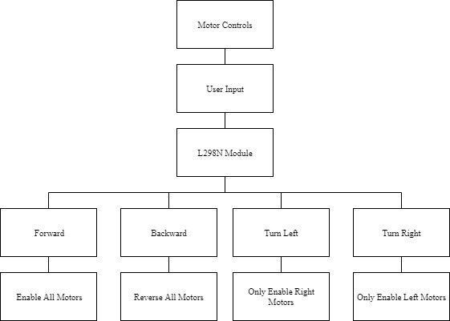
Figure 6: Motor Controls Structure Chart

Figure 6 depicts the structure of the motor controls of the DAT CAR. There are four TT DC motors that are connected to the wheels and controlled by the L298N module. The user interacts with the motors by inputting controls that are respective to the movements of DAT CAR. The four options of movement are forward, backward, turn left, and turn right. If the user inputs the forward command, then all the left side motors of the chassis rotates counterclockwise, while the right side rotates clockwise, thus enabling a forward motion. If a backward movement is inputted, then the left side of the chassis rotates clockwise, and the right side rotates counterclockwise to provide a backward motion. The turn left input enables the right-side wheels and rotates the chassis to the left. The right turn input enables the left side wheels and rotates the chassis to the right.
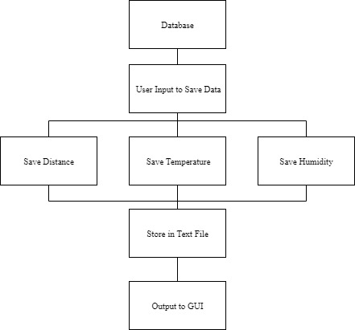
Figure 7: Database Structure Chart

Figure 7 depicts the structure of the database component of DAT CAR. The user can save the data that is displayed on the GUI by clicking the “Save Data” button. The current distance, temperature, and humidity data are then to be saved into a text file. The data that was saved is also shown on the GUI.
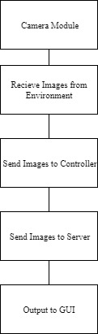
Figure 8: Camera Module Structure Chart

Figure 8 depicts the camera module structure in DAT CAR. The camera is enabled and takes images in succession to provide a video feed. The images capture are from the surrounding environment from DAT CAR. The video feed is sent to the controller software, which is then sent to the webserver. The web server displays the video feed on the GUI on the user’s client.
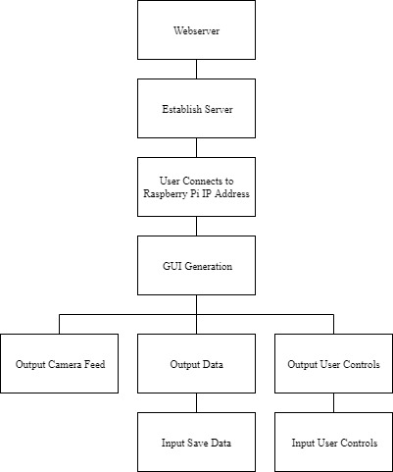
Figure 9: Web Server Structure Chart

Figure 9 depicts the structure of the web server component on DAT CAR. The controller software establishes a server. A user can connect to the server by inputting the Raspberry Pi’s IP address into a web browser. Once a user is connected to the Raspberry Pi, the GUI is generated for that user’s client. The GUI shows the video feed from the camera module, the output data from the sensors, and user controls of the motors on the RC car.

3.3 Software Behavior
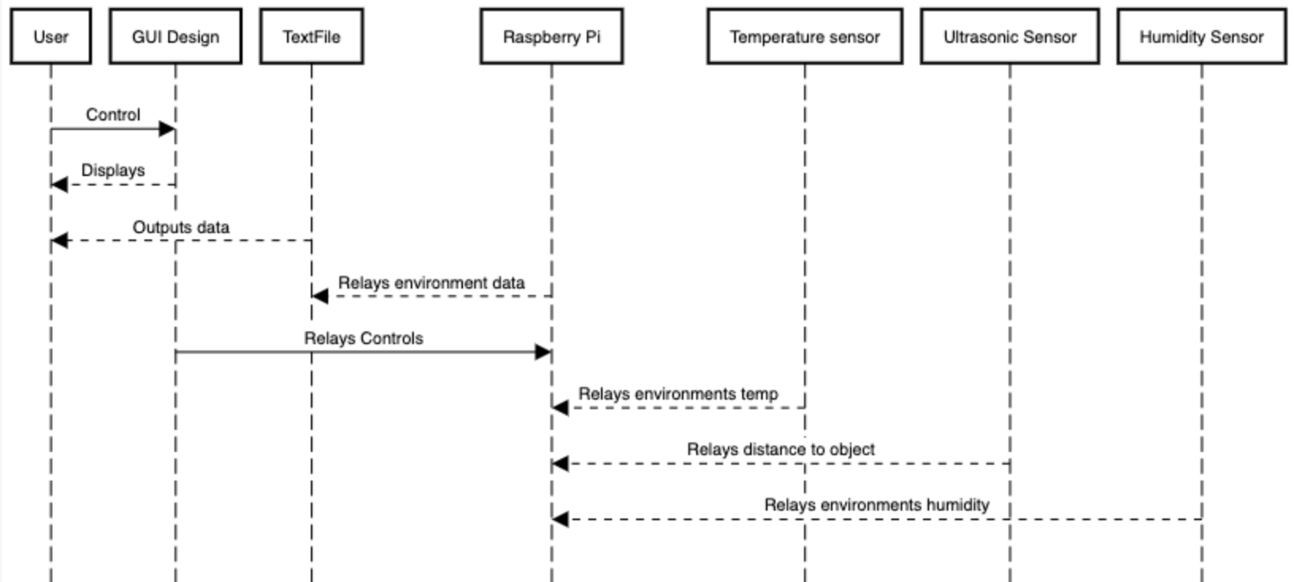
Figure 10: Sequence Diagram Displaying Software Behavior

Figure 10 depicts the communication between the modules in a time sequence. The software communicates with each other constantly. The sensor modules relay their readings when the user sends the control through the GUI Design to the Raspberry Pi. This data is transferred via Wi-Fi to be saved to a text file that is viewable to the User.

3.4 GUI Design
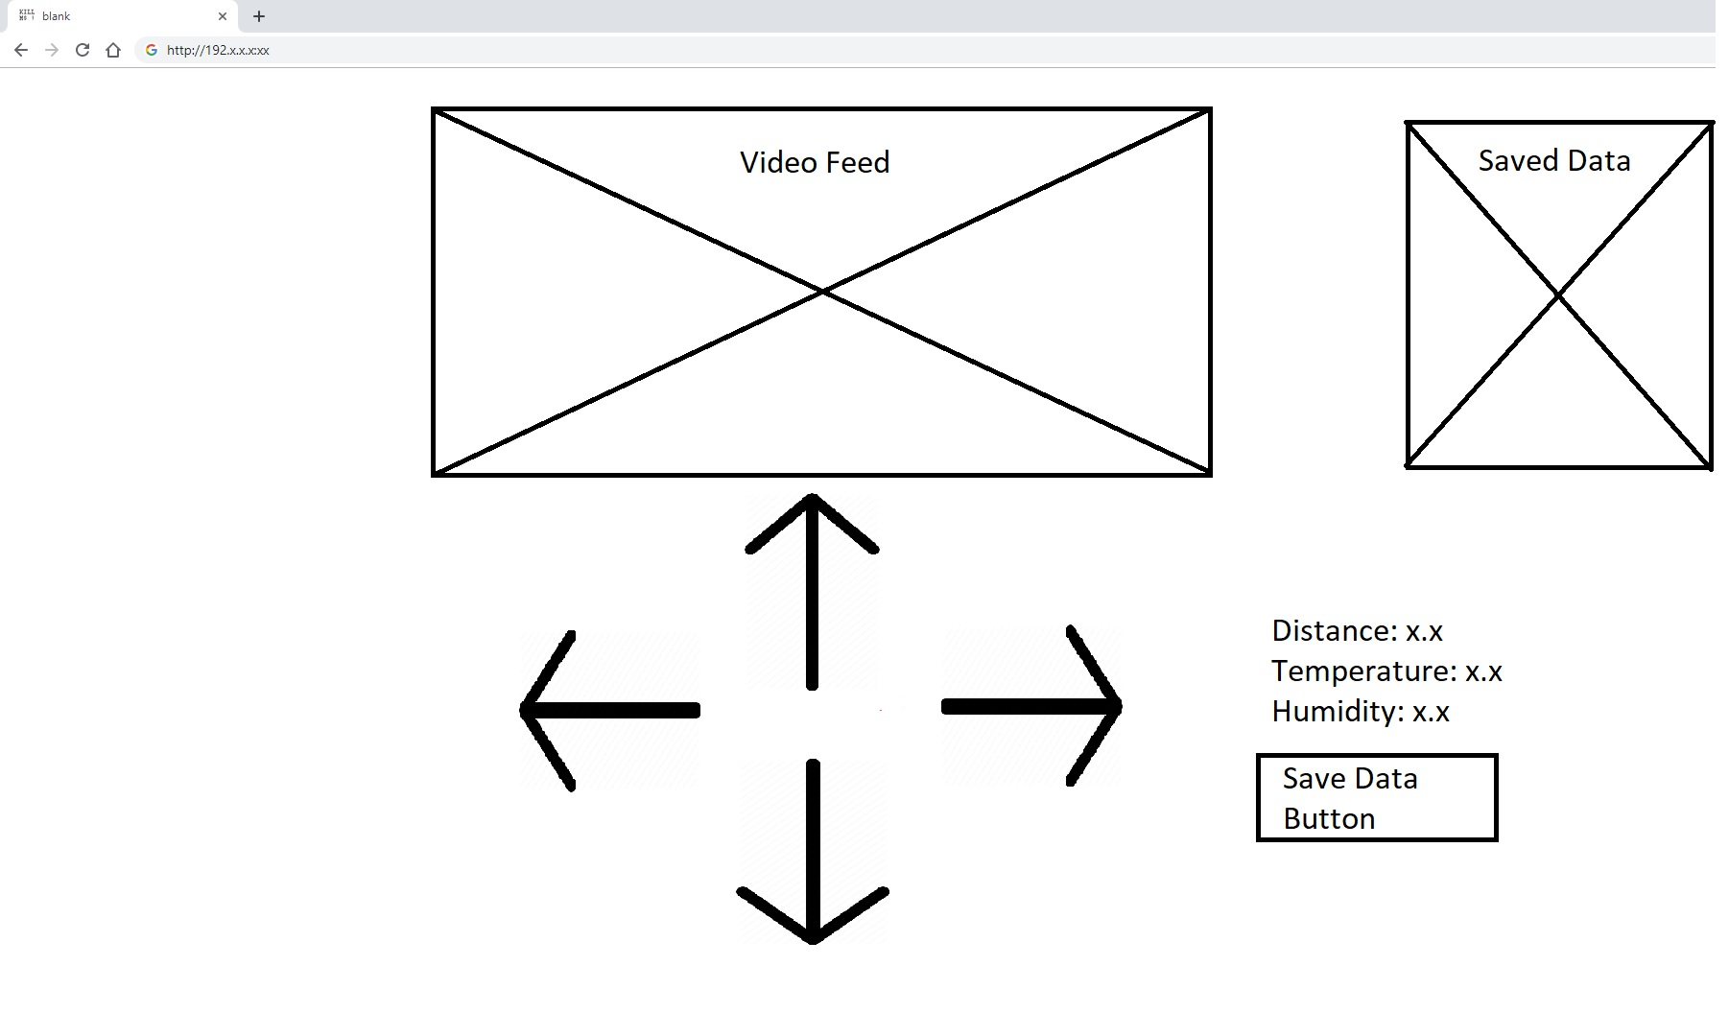
Figure 11: Mockup GUI of User Application

Figure 11 depicts the GUI Design for the project and how a user can control the DAT CAR via WiFi. A user can connect to the IP address of the microcontroller and this then displays the GUI design once connected. In Figure 11, the user can use the directional arrows in order to control the car. The GUI also contains a button that can save the current data of the environment; the system gathers the distance of an object in front of the car, as well as gather the temperature and the humidity of the environment surrounding the DAT CAR system.

4. Implementation and Testing
4.1 Assembly and Coding
4.1.1 Raspberry Pi 3 B+
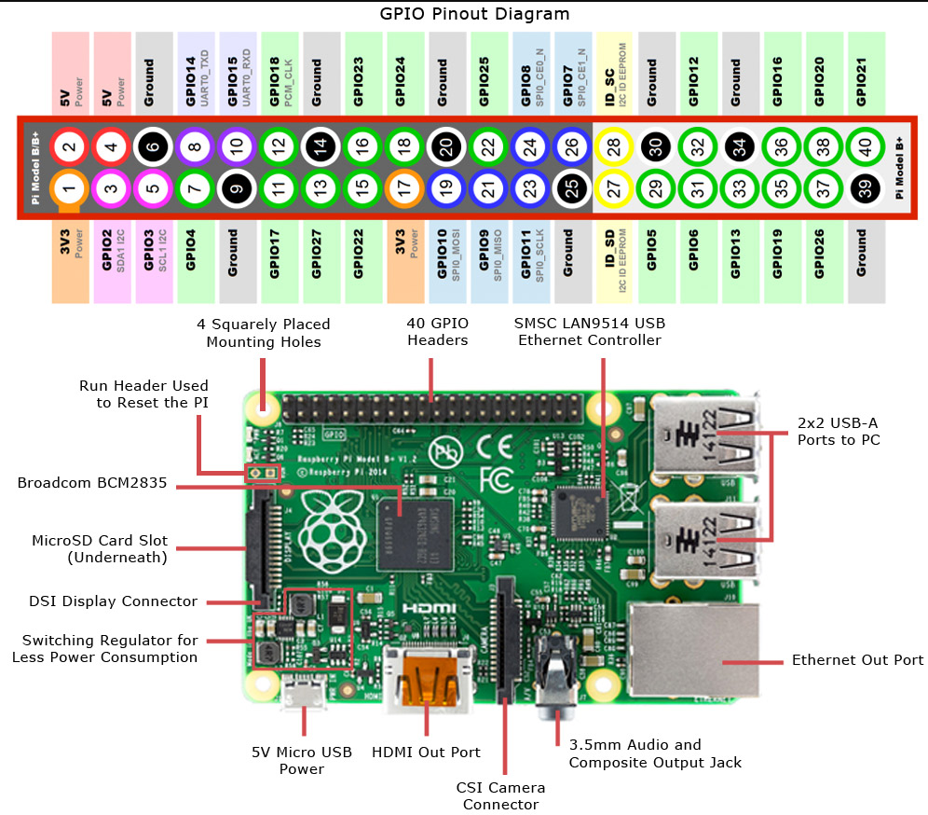
Figure 12: Raspberry Pi Pinout Diagram [3]

Figure 12 depicts the various input and output devices on the Raspberry Pi 3 B+, which is the controller software for the DAT CAR system. The Raspberry Pi is powered by a portable battery and connected to it with the 5V micro USB power port. Explicitly, this Raspberry Pi contains a single 40-pin expansion header with access to 28 general-purpose input/output (GPIO) pins. These pins are essential for the controller software. The ultrasonic, temperature and humidity sensors utilize the GPIO pins to gain power and transmit data to the Raspberry Pi. Utilizing a breadboard was done to connect the sensors to the Raspberry Pi as well. In addition, the GPIO pins power the motor module that is used to control the movements of the four TT DC motors and move the RC car chassis. A camera module is also used in this project and is connected to the CSI camera connector port to allow a live video feed to be sent to the end-user.
4.1.2 L298N Dual H-Bridge Module
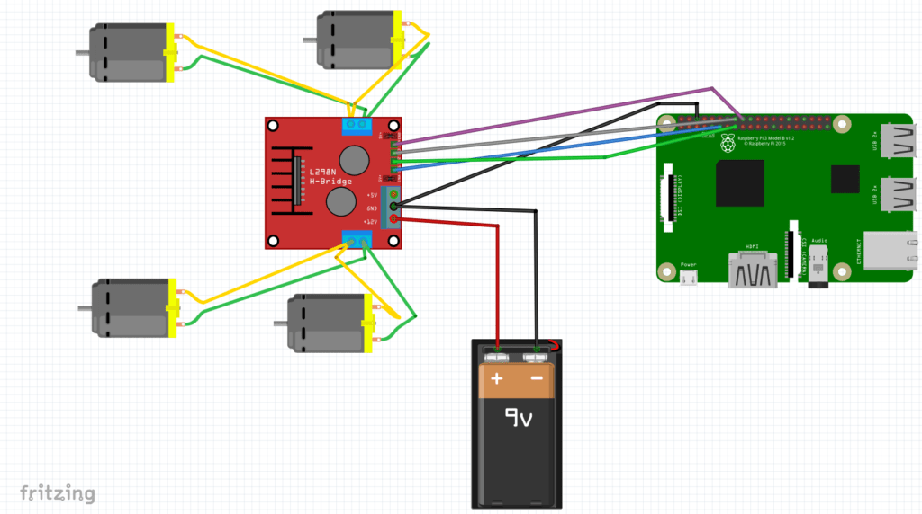
Figure 13: Circuit Diagram for Motor Module [4]

Figure 13 depicts how the four TT DC gear motors gain power via the L298N Dual H-Bridge Module. The motor module is powered by a 9v battery. Each of the TT DC motors is connected to the motor module with a power and grounding wire. The motor module is connected to the Raspberry Pi through the GPIO pins at port 17, 22, 23, and 24 along with a grounding pin. GPIO programming is used to control the motors by activating the input and output ports on the L298N module. This Dual H-Bridge module has a separate battery source from the Raspberry Pi. Separate batteries are used as a precaution to back EMF. This event can occur when any inductor, the motor coil in this instance, is switched off. The motor coil can produce a huge voltage spike and may terminate a control circuit.

m11=17
m12=22
m21=23
m22=24

GPIO.setmode(GPIO.BCM)
GPIO.setup(m11, GPIO.OUT)
GPIO.setup(m12, GPIO.OUT)
GPIO.setup(m21, GPIO.OUT)
GPIO.setup(m22, GPIO.OUT)
GPIO.output(m11 , 0)
GPIO.output(m12 , 0)
GPIO.output(m21, 0)
GPIO.output(m22, 0)

@app.route('/turn_left')
def left_side():
data1="LEFT"
GPIO.output(m11 , 0)
GPIO.output(m12 , 0)
GPIO.output(m21 , 1)
GPIO.output(m22 , 0)
return 'true'

@app.route('/turn_right')
def right_side():
data1="RIGHT"
GPIO.output(m11 , 1)
GPIO.output(m12 , 0)
GPIO.output(m21 , 0)
GPIO.output(m22 , 0)
return 'true'

@app.route('/go_forward')
def up_side():
data1="FORWARD"
GPIO.output(m11 , 1)
GPIO.output(m12 , 0)
GPIO.output(m21 , 1)
GPIO.output(m22 , 0)
return 'true'

@app.route('/go_backward')
def down_side():
data1="BACK"
GPIO.output(m11 , 0)
GPIO.output(m12 , 1)
GPIO.output(m21 , 0)
GPIO.output(m22 , 1)
return 'true'

@app.route('/stop')
def stop():
data1="STOP"
GPIO.output(m11 , 0)
GPIO.output(m12 , 0)
GPIO.output(m21 , 0)
GPIO.output(m22 , 0)
return 'true'

The Python code snippet depicts the setup of the GPIO pins for the motor module, as well as the functions defining respective movements of the chassis. The variables m11, m12, m21, and m22 are assigned numbers that are associated with the pin number on the Raspberry Pi. The GPIO.setmode (GPIO.BCM) is referring to the pins by the “Broadcom SOC channel” number. The numbers can be seen after “GPIO” in the green rectangles in Figure 12. The GPIO.setup section declares the “pin modes” that are being used for the motor module. The GPIO output section writes the pin values as the boolean value 0, or false. The @app.route that are before defined functions is a built-in wrapper in Flask for generating routes. The routes are referring to the HTML file that is used in the project. When a respective button is clicked on the GUI, the HTML code calls the function that is associated with the specific route. There are five functions defined that are responsible for executing the movements of the chassis. The five functions defined are moving forward, backward, left, right, and stop. Each of the functions sets the output of the motor module to either false or true and depending on the output, the four TT DC motors of the wheels will either be on or off and are either moving clockwise or counterclockwise.

4.1.3 Ultrasonic Sensor
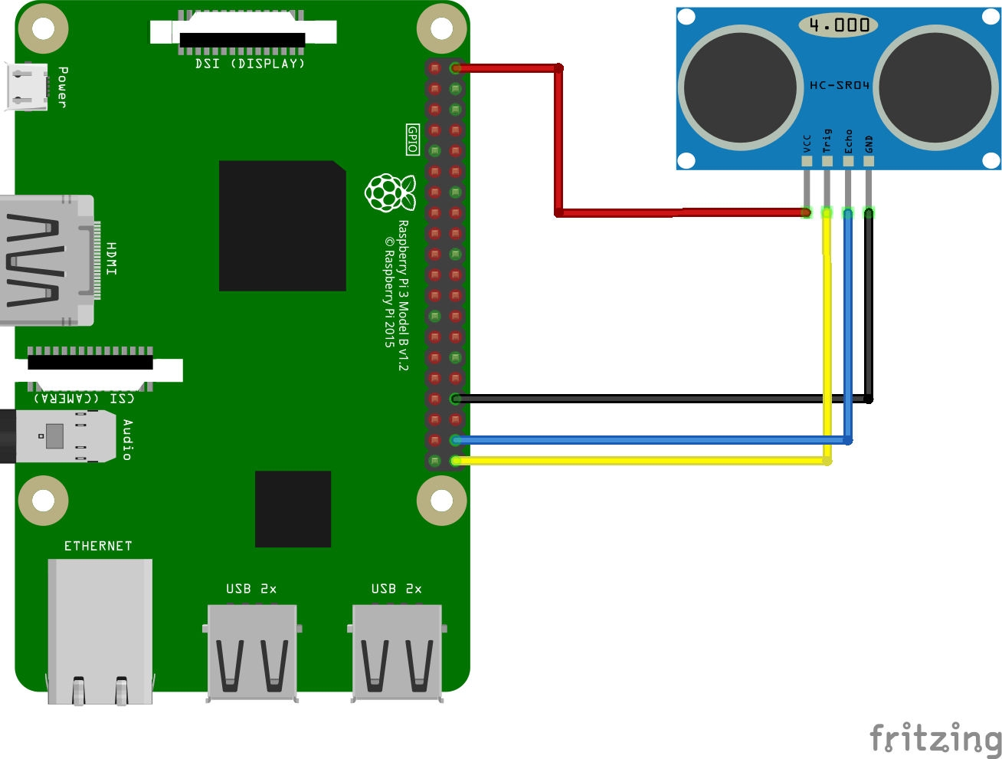
Figure 14: Circuit Diagram for Ultrasonic Sensor [5]

Figure 14 depicts how the Ultrasonic Sensor was connected to the Raspberry Pi. An HC-SR04 was used for this project. A breadboard was utilized with reference to the diagram to connect the sensor to the Raspberry Pi. Ports 21 and 20 are connected to the sensor along with the 5v power and ground pins. With the use of a breadboard, it could be successfully mounted to the chassis with the sensor pointing out in front of the car. The ultrasonic sensor emits soundwaves that reflect on objects in front of it. The reflected sound is calculated by the sensor to find the distance of an object in front of it. The sensor communicates to the Raspberry Pi module via GPIO pins, thus allowing the module to read and write. The data is then transferred to the Raspberry Pi. The Raspberry Pi sends the data from the sensor to the GUI interface that is established on the server.

TRIG = 21
ECHO = 20

GPIO.setmode(GPIO.BCM)
GPIO.setup(TRIG,GPIO.OUT)
GPIO.setup(ECHO,GPIO.IN)

def findDistance():
GPIO.output(TRIG, False)
print ("Waiting For Sensor To Settle")
time.sleep(2)

GPIO.output(TRIG, True)
time.sleep(0.00001)
GPIO.output(TRIG, False)

while GPIO.input(ECHO)==0:
pulse_start = time.time()

while GPIO.input(ECHO)==1:
pulse_end = time.time()

pulse_duration = pulse_end - pulse_start

global distance

distance = pulse_duration * 17150

distance = round(distance, 2)

print ("Distance:",distance,"cm")

return 'true'

The Python code snippet depicts the setup of the GPIO pins for the ultrasonic sensor, as well as the function that calculates the distance. The variables TRIG and ECHO are assigned numbers that are associated with the pin number on the raspberry pi. The GPIO.setmode(GPIO.BCM) is referring to the pins by the “Broadcom SOC channel” number. The numbers are after “GPIO” in the green rectangles in Figure 12. The GPIO.setup section declares the “pin modes” that are being used for the ultrasonic sensor. The GPIO output section writes the pin values as 0, or false. The “findDistance()” function uses both a trigger (TRIG) and an echo. The trigger pin is used to trigger the ultrasonic sound pulses, while the echo pin produces a pulse when the reflected signal is received. The length of the pulse is proportional to the time it took for the transmitted signal to be detected [8]. The function calculates the distance between the two variables.

4.1.4 Temperature and Humidity Sensor

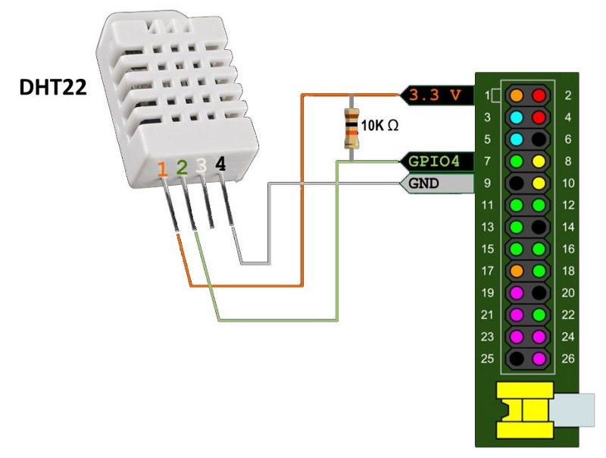
Figure 15: Temperature and Humidity Sensor Circuit Diagram [6]

Figure 15 displays how the temperature and humidity module is connected to the Raspberry Pi GPIO pins. A DHT22 was used for this project. A breadboard was used to connect the temperature and humidity sensor to the Raspberry Pi with reference to the diagram. GPIO pin 4 is used along with the 3.3v power and grounding pins. The sensor module detects the temperature of the environment as well as the capacitive humidity of the environment. The sensor module contains four pins. Pin 1 is for the Power supply. Pin 2 is for Data collection. Pin 3 is not to be connected to the Raspberry Pi module. The last one, Pin 4 is the grounding pin. The sensor also utilizes a 10k ohm resistor to control the flow of the current and limit it.

import Adafruit_DHT

DHT_SENSOR = Adafruit_DHT.DHT22
DHT_PIN = 4

GPIO.setmode(GPIO.BCM)

def findTempHumi():
humidity, temperature = Adafruit_DHT.read_retry(DHT_SENSOR,
DHT_PIN)
global tempHumi

tempHumi="Temp={0:0.1f}*CHumidity={1:0.1f}%\n".format(temperature,humidity)
return 'true'

The Python code snippet depicts the setup of the GPIO pins for the temperature and humidity sensor, as well as the function that calculates the temperature and humidity. The function also formats the output of the temperature and humidity. The code imports the Adafruit_DHT library. The variable DHT_Sensor is assigned a value that is associated with the DHT22 sensor in the Adafruit_DHT library. The variable DHT_PIN is assigned the number that is associated with the pin that it is plugged into on Raspberry Pi’s GPIO board. The GPIO.setmode(GPIO.BCM) is referring to the pins by the “Broadcom SOC channel” number. The numbers are after “GPIO” in the green rectangles in Figure 12. The imported library contains the code for the DHT22 sensor. The temperature and humidity variables are assigned a value that is found by calling a function within the Adafruit_DHT library that calculates the temperature and humidity. The calculated values are then formatted in a new variable called “tempHumi”.
4.1.5 Raspberry Pi Camera Module
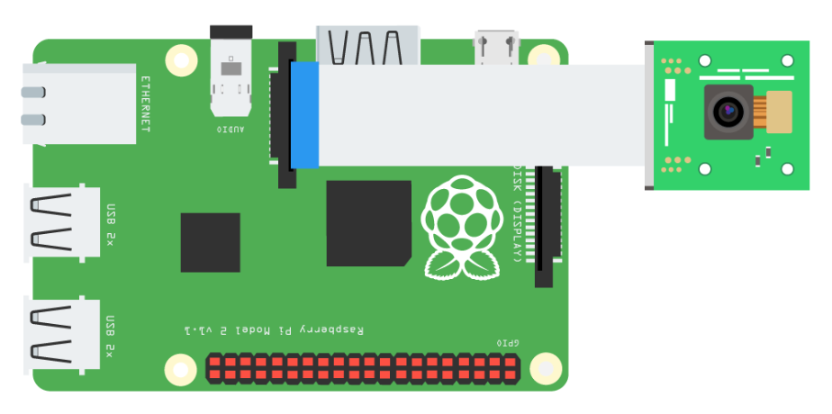
Figure 16: Camera Module Diagram [7]

Figure 16 shows a camera module inserted into the CSI camera connector port. Python is used for photo imaging within this project. The python code allows for the server to turn on the camera module and stream it to the user application. The camera is utilized so that the user can see where the RC Car is located and can use the controls appropriately. Depending on the internet connection, the latency of the camera should be less than five seconds. If a user is connected to the same network, then the latency is less than four seconds. If the internet speed has at least 5mb download speeds and 5mb upload speeds, then the latency is less than one second.
from camera_pi import Camera

def gen(camera):
while True:
frame = camera.get_frame()
yield (b'--frame\r\n'
b'Content-Type: image/jpeg\r\n\r\n' + frame + b'\r\n')

#Stream the video to the html file
@app.route('/video_feed')
def video_feed():
return Response(gen(Camera()),
mimetype='multipart/x-mixed-replace; boundary=frame')

The code snippet depicts the camera being created and streamed to the HTML file. The code imports the file camera_pi.py by Marcelo Rovai [8]. The camera_pi.py code establishes a class named Camera with an object parameter. Within the code, it initializes the camera, gets the frames, sets the resolution, and continuously captures new frames. In the code snippet, the first function generates a camera object and retrieves the frames. The second function, “def video_feed()” streams the video through a Flask application route, where it is the source of an image in the HTML code.
4.1.6 Database
@app.route('/save_data')
def saveSensorData():
findTempHumi()
findDistance()
f = open("saved data.txt", "a+")
f.write("Distance was %d" % distance + "cm\n")
f.write(tempHumi + "\n")
f.close()
return 'true'

The database that is used in the project is a text file. The code snippet routes the “saveSensorData” function when a certain button is clicked on the GUI. Within the function, the “findTempHumi” function is called that calculates the current temperature and humidity. The “findDistance” function is also called that calculates the distance of an object in front of the ultrasonic sensor. Within the directory of the python script, the code opens a text file named “saved data.txt”, and if it does not exist, then it creates the file. It is defined in the parameters of line five that it appends information to the file, so no information already in the file is overwritten. The distance value is appended to the text file followed by the temperature and humidity values. The file is closed, and the function is done executing.
4.1.7 Web Server
from flask import Flask
from flask import render_template, request
from flask import Response

app = Flask(__name__)

def index():
findDistance()
findTempHumi()
return render_template('testWeb.html', dist=distance, temp=tempHumi)

if __name__ == "__main__":
print ("Start")
app.run(host='0.0.0.0',port=5010, debug=True, threaded=True)

The web server that is established with the controller software utilizes Flask. The code snippet imports the Flask files so a web server can be established. A variable named “app” is declared and instantiated with a Flask object. The function “index” is used and renders an HTML template. In addition, the function calls “findDistance” and “findTempHumi” functions to pass variables to the HTML code. The variables contain sensor data that are displayed on the GUI. At the end of the code snippet, a web server is being established. The IP address that is set is the local host’s IP address. The port number is 5010. With the IP address and port number, a user can connect to the webserver by inputting the IP address followed by a colon then the port number. As a result of Flask, other functions can be routed to the webserver.
4.1.8 Final Assembly
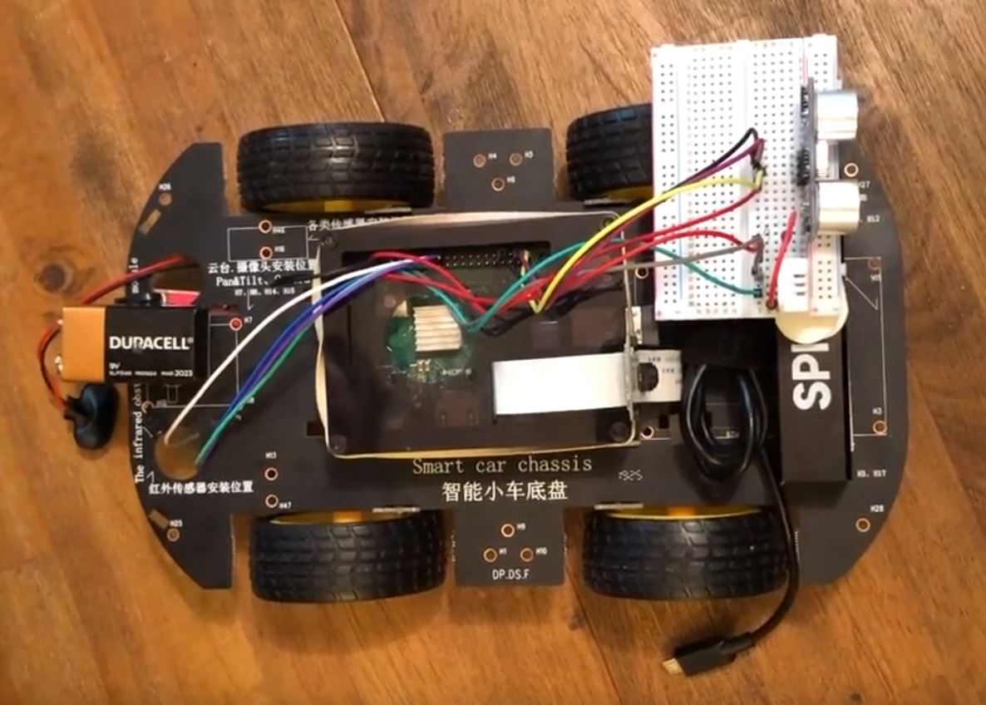
Figure 17: Complete DAT CAR Assembly

Figure 17 shows the final assembly of the DAT CAR. The housing of the Raspberry Pi is attached to the top of the chassis with the use of Velcro strips. The power supply for the Raspberry Pi is also attached near the front of the chassis where it is used as a fastening point for the sensors connected to the breadboard. Near the rear of the chassis is the 9v battery that is attached to the motor module. The motor module is underneath the chassis and is attached with zip ties. The wiring to each component is done with respect to their diagrams from previous sections. A rubber band is wrapped around the case of the Raspberry Pi and the ribbon for the camera module. This method allows the camera to be upright and pointed to the front of the chassis.
4.2 Testing
Test Case | 1
Requirement | 2.4.2 - 5: The client software shall be able to move the RC car left, right, forward, and backward by clicking the respective buttons on the GUI.
Input | User clicks left, right, forward, and backward buttons on the GUI
Output | DAT CAR correctly moves into the respective direction that is selected on the GUI.
Post-test discussion:
The specific requirement has been met with test case 1. However, in testing, it was found that when a user presses a button and drags the pointer off of the button then releases the button, the button continuously registers itself as being pressed. DAT CAR continuously moves in the direction of the bugged button until a button is pressed and depressed with the cursor over the button. This discrepancy is prompted because the user may not want the chassis to move in the direction of the bugged button. A suggestion for the user is to always have the cursor over the button while it is being pressed and depressed. A suggestion for the development team is to add JavaScript code that depresses the button when the cursor is no longer over the button.

Test Case | 2
Requirement | 2.4.1 - 3: The controller software shall be able to save distance, temperature and humidity data into a text file.
Input | The user selects the “Save Data” button on the GUI which calls the controller software to save distance, temperature, and humidity values into a text file.
Output | The controller software calls the distance, temperature and humidity functions then appends the values to a text file named “saved data” within the folder where the source code is located. If the file named saved data does not exist, then the controller software creates the text file.

Post-test discussion:
The specific requirement has been met with test case 2. There is no discrepancy between the requirement and actual results.
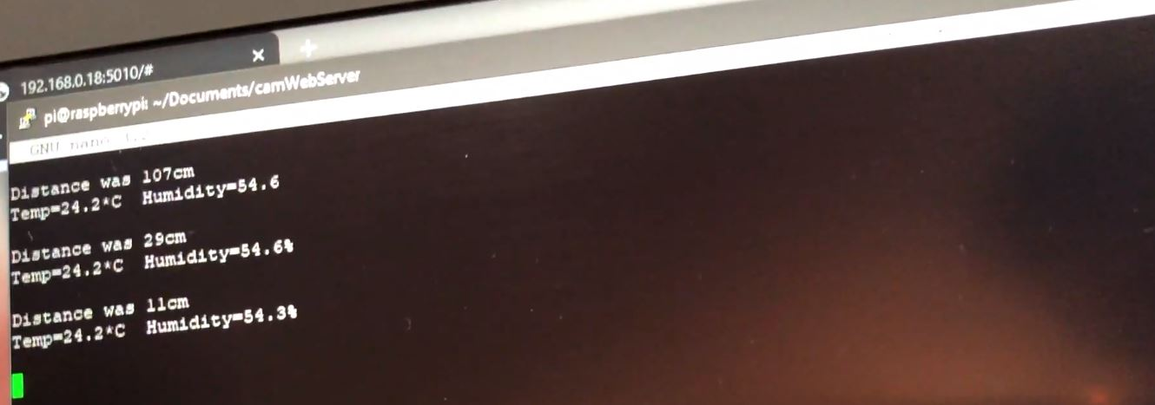
Figure 18: Sensor Data in Text File

Figure 18 shows the appended sensor data in a text file. The distance, temperature, and humidity values were correctly stored in the text file.

Test Case | 3
Requirement | 2.4.3 - 6: The DAT CAR system shall boot up in under 30 seconds after it is turned on.
Input | The controller software (Raspberry Pi) is turned on by a portable power supply.
Output | The controller software script is running on the bootup of the raspberry pi.
Post-test discussion:
The specific requirement has not been met with test case 3. There is a discrepancy between the requirement and the results. After DAT CAR is turned on, it took around 60 seconds to successfully run the controller software scripts. There are three suggestions for the discrepancy. The first suggestion would be to add a physical button on DAT CAR that can run the script to start the controller software, which should boot up almost immediately if the Raspberry Pi is already on. The second suggestion is to upgrade the Raspberry Pi, therefore decreasing bootup times. The third suggestion is to edit the requirement with post knowledge on the software.
Test Case | 4
Requirement | 2.4.1 - 5: The controller software shall utilize a camera and stream images to the client software.
Input | A Raspberry Pi camera module is used. A camera object is created, and images are taken from the Raspberry Pi camera module that are streamed to the client software GUI
Output | The client software GUI receives the images and updates the source when a new one is received.
Post-test discussion:
The specific requirement has been met with test case 4. There is no discrepancy between the requirement and the results. The time in which the source image is updated is dependent on the internet upload and connection speeds on the controller and client software.
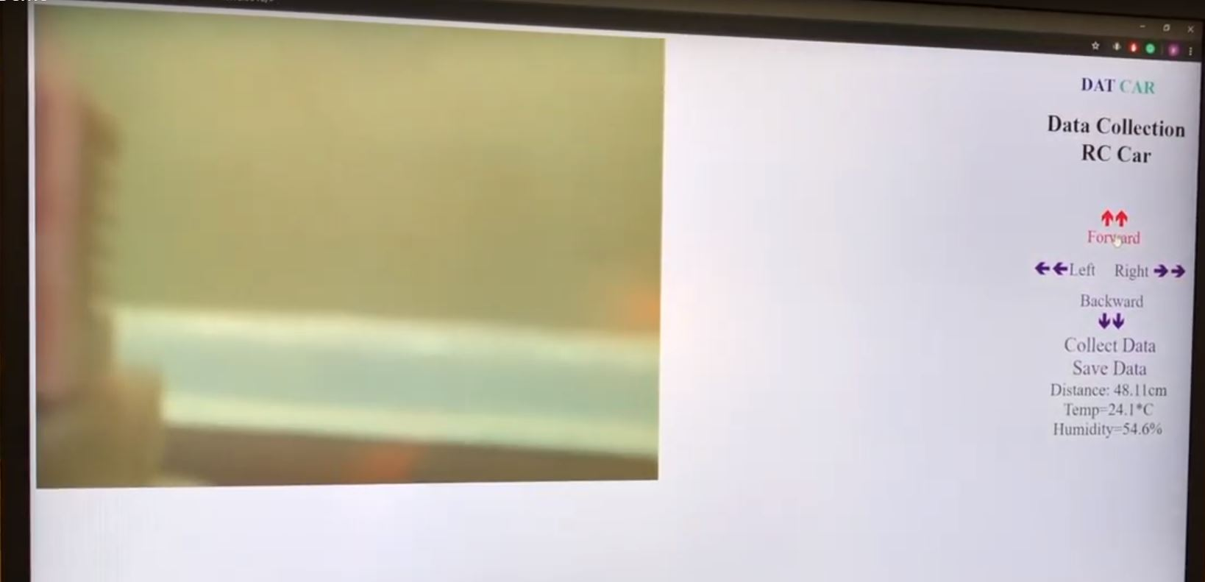
Figure 19: GUI for DAT CAR

Figure 19 shows the GUI for the client software. The image on the left side of the GUI is taken from the camera module. The camera is taking multiple images and the controller software is streaming the images to the client software GUI. The source image in the HTML file is updated, therefore streaming images and creating a video stream.
5. Conclusion
DAT CAR was able to successfully collect data based on the environment’s distance, temperature, and humidity with the use of web controls that activated the sensors and manipulated the movement of the chassis. There are five main components to the software architecture that define DAT CAR, which are the sensors, motors, camera, database, and the webserver.
The sensors that were successfully implemented on the DAT CAR system were: an ultrasonic sensor and a temperature with a humidity sensor. All the sensors are able to accurately collect data on the environment surrounding the DAT CAR system. The difficulty of this component was the circuitry. The team for this project were inexperienced with wiring and circuits. Many hours have to be contributed to understand circuitry to ensure no components of DAT CAR were damaged.
The motor module was the first component that was successfully implemented in the project. The only complications with the motor module component was the wheel movements when they are activated. Some of the wheels would not turn in the proper direction to initiate movements of the chassis in the respective direction. The solution was just trial and error on the Python code that activated the wheel motors until they function properly.
The camera component was pointed to the front of the DAT CAR system giving the user a view of the front of the system in order to view and traverse the environment. The camera module is located right next to the sensors, this allows for the user to point the camera at the object they would like to gain data from, and the sensors are also then aligned. The GUI then displays the values in large text and formatted in a way so that the user can easily understand. Before utilizing the camera_pi.py import file, Motion was used. Motion is a highly configurable program that monitors video signals from many types of cameras [10]. However, there were many complications with the program. As a result of the dilemma that occurred with Motion, it was found to be more efficient to import the camera_pi.py file.
The original database was going to an SQL one. However, there were many complications that occurred with the SQL database. As a result, a text file was used to append sensor data. The text file is saved on the Raspberry Pi system and can be accessed from a separate computer using PuTTY. Another method to access the text file is to connect the Raspberry Pi to a monitor and navigate to the directory that the file is located at.
The web server component was troublesome at first. Initially, the project was using Apache, which is a deployable webserver to run Python applications. The difficulty for the project arose when multiple components had to be implemented with the Apache webserver. Upon further research on deployable web server tools, it was found that using Flask lead to a successful establishment of a web server. Flask is a Python web framework built with a small core and easy-to-extend philosophy [11].
The GUI on the client software was also redesigned. For the new GUI design, the display is on the left side of the monitor with the directions on how to use the system on the right as well as the buttons used to collect and save the data of the environment. The team has changed the design so that a user can have an easier time reading the displayed data as well as knowing how to control the system.
There is much potential for expansion in this project. A suggestion is to update the software used for the database. SQL is an example that can replace the text file database. As of now, the movements of DAT CAR is restricted to a linear plane. Extensions to DAT CAR giving it airborne qualities is a highly desirable trait because it is no longer be restricted on ground surfaces. Additionally, DAT CAR does not have defense measures against the other autonomous robots or organisms in various environments. Possible extensions could be adding a flamethrower to the chassis. A flamethrower is a military assault weapon that projects a stream of blazing oil or thickened gasoline against enemy positions [12]. A weapon like a flamethrower would greatly increase DAT CAR’s survival in unknown exploration expeditions where predators may be present.
6. References
[1] Lucy Hattersley, “Raspberry Pi 3B+ Specs and Benchmarks”, The MagPi Magazine, 2018, https://magpi.raspberrypi.org/articles/raspberry-pi-3bplus-specs-benchmarks
[2] Xiaor Geek, “4WD Robot Chassis Kit with 4 TT Motor for Arduino/Raspberry Pi”, Amazon, Amazon, N/A date, https://amzn.to/2MvFHtV
[3] Jameco, “Raspberry Pi Pinout Diagram | Circuit Notes”, Jameco, N/A Date https://www.jameco.com/Jameco/workshop/circuitnotes/raspberry-pi-circuit-note.html
[4] Piddler, “L298N Dual H-Bridge”, PiddlerInTheRoot, February 18th, 2017,
http://www.piddlerintheroot.com/l298n-dual-h-bridge/
[5] Daniel Dallos, “Android Things Basics: Measure distance with Ultrasonic sensor”, Hackernoon, January 15th, 2017, https://hackernoon.com/android-things-basics-measure-distance-with-ultrasonic-sensor-3196fe5d7d7c
[6] Cloud4RPi, “Temperature and Humidity Monitoring Using Raspberry Pi”, Instructables, N/A Date, https://www.instructables.com/id/Temperature-and-Humidity-Monitoring-Using-Raspberr/
[7] Don Wilcher, “How to Build a Raspberry Pi Camera”, AllAboutCircuits, 2016, https://www.allaboutcircuits.com/projects/how-to-build-a-picamera/
[8] lastminuteengineers, “HOW HC-SR04 Ultrasonic Sensor Works & Interface it with Arduino”, Last Minute Engineers, N/A date, https://lastminuteengineers.com/arduino-sr04-ultrasonic-sensor-tutorial/
[9] Marcelo Rovai, “Video-Streaming-With-Flask”, Github, January 26th, 2018, https://github.com/Mjrovai/Video-Streaming-with-Flask/blob/master/camWebServer/camera_pi.py
[10] Motion, “About Motion”, motion-project, N/A date, https://motion-project.github.io/index.html
[11] Matt Makai, “Flask web development, one drop at a time”, Full Stack Python, 2012-2019, https://www.fullstackpython.com/flask.html
[12] The Editors of Encyclopaedia Britannica, “Flame thrower”, Britannica, N/A date, https://www.britannica.com/technology/flame-thrower

